The Magnificent Story

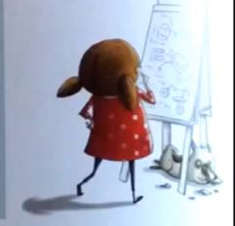
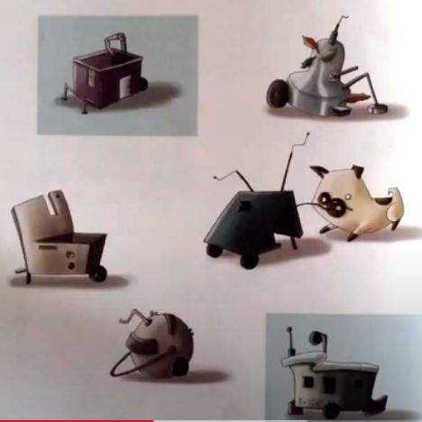

She tries different way to make it better. Nothing works
The girl decides to make a magnificent thing

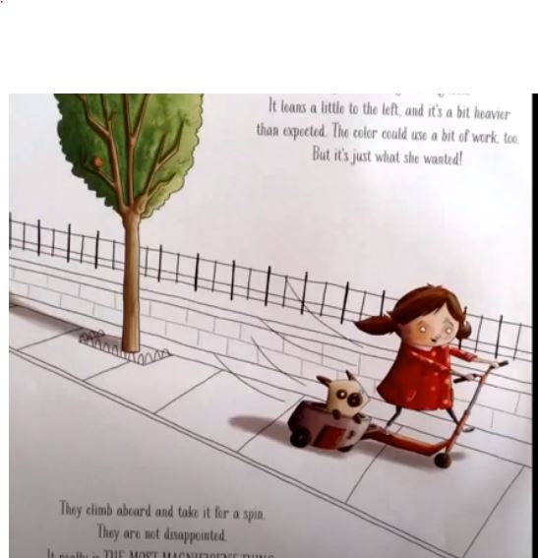



But eventually, after working carefully, she does the magnificent thing.

She becomes frustrated when nothing seems to work.

The Magnificent Story
The girl decides to make a magnificent thing. She tries different ways to make it better. Nothing works! But finally, after working carefully, she does the magnificent thing. She becomes frustrated when nothing seems to work. But eventually, after working carefully, she does the magnificent thing.

